Welcome to Firstbeat Lifestyle Assessment
Starting the measurement

Start the measurement in the morning immediately after waking up. The measurement lasts 3 consecutive days and nights, and it is recommended to measure 2 working days and 1 day off. Start the measurement within one week after receiving the device, unless a different schedule has been agreed on.

Make sure that you have received an email from service@firstbeat.fi to start the Lifestyle Assessment. The message will be sent to you on ______. ______ . _________
How to attach the device

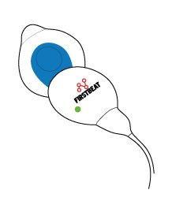
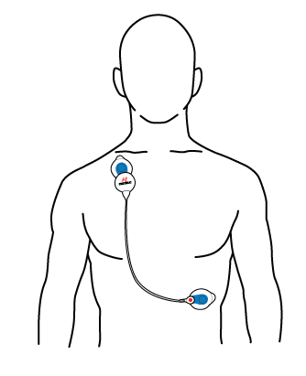
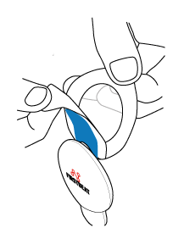
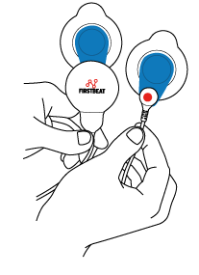
4. The measurement starts automatically when device is attached. Make sure the green led is flashing. Note: the light is easiest to see in a dark room.
3. Attach the device end to the right side of the body under the collarbone. The cable end is attached to the left side of the body on the rib cage.
2. Remove the cover. Ensure that your skin is clean and dry before you attach the electrode.
1. Attach the electrodes to the cable and device end.

During the measurement

Fill your background information and measurement journal. You can access them via the link in the welcome email. Note! The information is confidential and will only be seen by the specialist conducting the assessment!

The electrodes are disposable. Change them at least once per day, for example after taking a shower. Please note that chest hair weakens electrode contact. We recommend shaving off excess hair from the electrode site. The glue or electrode paste can irritate your skin. You can avoid this by slightly changing the electrode location. If you suspect an allergic reaction, stop the measurement and look here for instructions https://www.firstbeat.com/en/support/faq/
A flashing green light means that the device is recording heart rate data. If you can’t see a green light (notice that the light is dim!) or you see a different colour light, contact support@firstbeat.com.

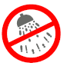
Using the device in water is forbidden. Detach the device during swimming, shower and sauna. The recording will continue automatically when you re-attach the device.
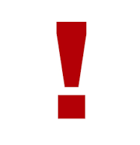
The measurement device and starting email are personal. If you can’t conduct the measurement, please return the device unused.

After the measurement

- End the measurement after 3-days by detaching the device from your body. The measurement will end automatically.
- Return the device and the form below to your personal contact person as soon as you are done with the measurement.
- Please remember to fill in your personal details and measurement journal!
- After the measurement, you will get the reports and feedback of your measurement result, as well as suggestions for further actions.

Happy measurements!
(Name of specialist)
(Company name)
(Address)
----------------------------------------------------------------------------------------------------------------------
PLEASE RETURN THIS SLIP FILLED TOGETHER WITH YOUR DEVICE

Name:
Phone number:
E-mail address:
Device serial number (on the backside of the device, ‘LOT BG xxx’):
Measurement starting date and time: ______.______.2020 at _______:________
- I did not conduct the measurement. I am returning the device unused.

